A000-Asia-Persia-Luristan-Master of Animals-Finial for Ceremonial Standard

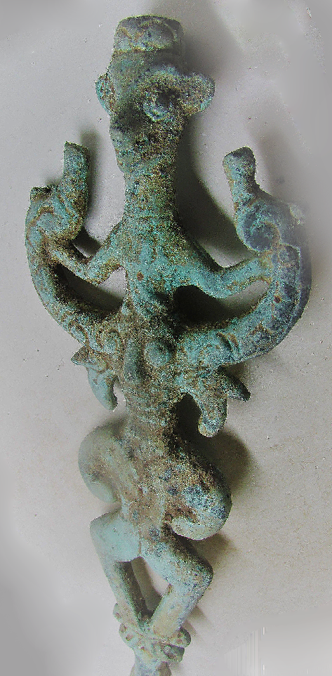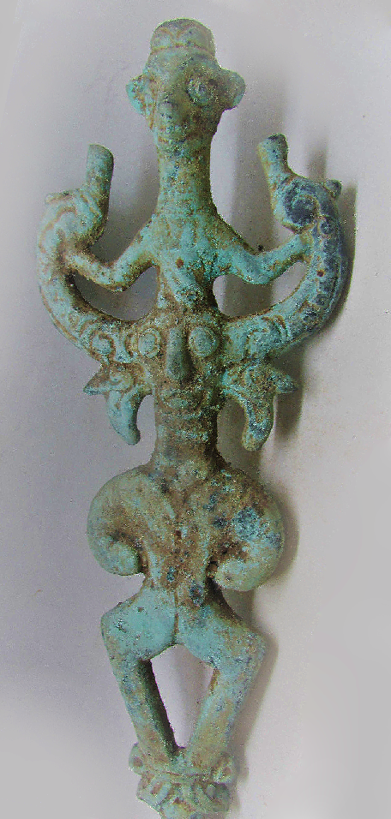

 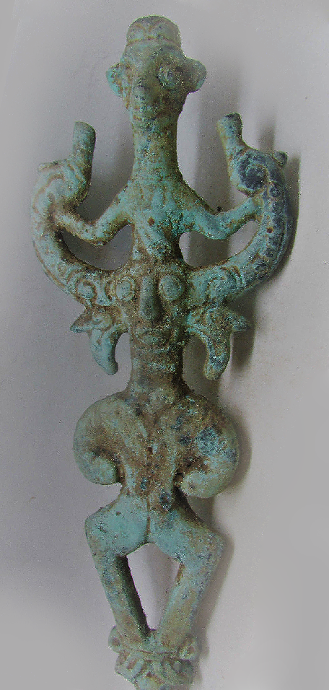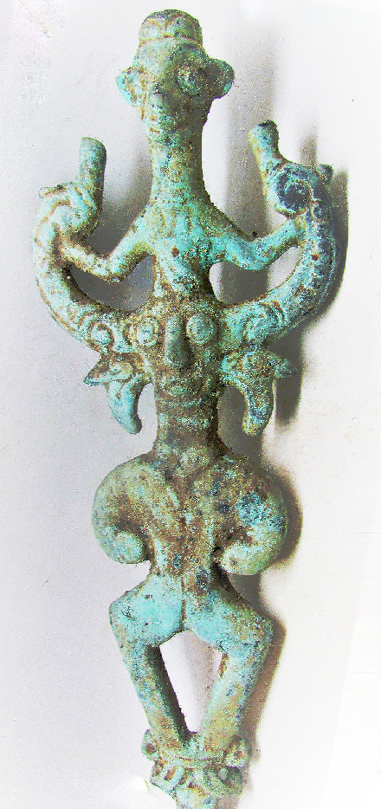

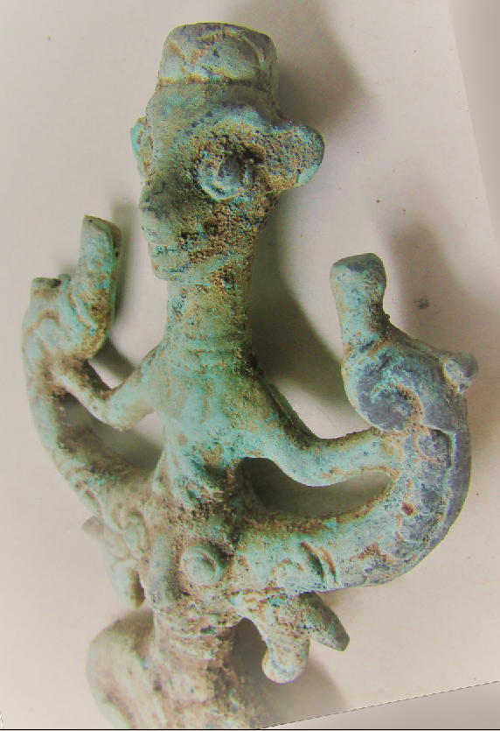

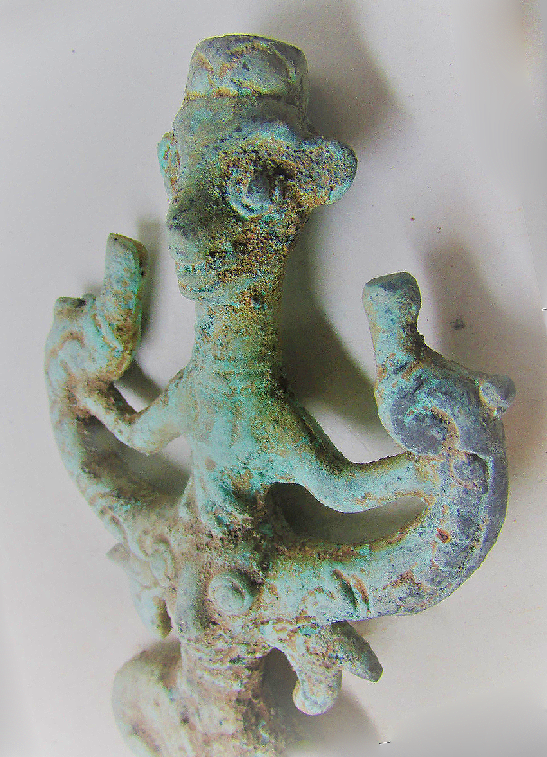

Figs. 1-7 Asia-Persia-Luristan-Master of Animals-Finial for Ceremonial Standard

**Case no.: 4**

**Accession Number:**

**Formal Label:**

Asia-Persia-Luristan-Master of Animals-Finial for Ceremonial Standard

**Display Description:**

The label “Luristan bronzes” (see [BRONZES OF LURISTAN](http://www.iranicaonline.org/articles/bronzes-of-luristan)) designates a series of decorated bronze objects in a specific local style dating from the Iron Age (ca. 1300/1250 to 700/650 BCE). These bronzes became known through large-scale illegal excavations starting in the late 1920s, but their cultural context and provenance remained uncertain for a long time and the label is often wrongfully used—usually for commercial reasons—for bronze objects from other regions or periods. The canonical Luristan bronzes belong to the geographical region of Luristan (present-day provinces of Lorestān and Ilām; [FIGURE 1](http://www.iranicaonline.org/uploads/files/luristan_i_fig_1.jpg)) and include lost wax casts as well as sheet metal objects. Although few Luristan bronzes were found during controlled excavations, it is ascertained that the majority came from tombs, while one specific category (pins with decorated heads) have up to now only been found as ex-votos in a sanctuary. They mainly date to the Early Iron Age and are rare in Iron Age III (Overlaet, 2005, pp. 9-16).

*Style and repertory.* The Luristan style is characterized by stylized human and animal forms, often combined to create fantastic creatures. Humans, birds, snakes, horses, bovid and feline species, and several species of goats are the main components. Vegetal elements are mostly used in a “tree of life” capacity, as border motifs or as filler motifs in between the principal iconography. The available evidence points to a chronological evolution from simple naturalistic themes to more complicated and fantastic creations.

There are several categories of objects that display the Luristan style. Horse gear includes horse-harness trappings and horse bits with decorative cheek pieces. Arms and equipment include spiked axe heads, adzes, daggers, swords, whetstone handles, and quiver plaques. Among the jewelry are rings, bracelets, pendants, and pins with cast or hammered sheet metal heads. An important series are the so-called “idols,” also labeled “finials” or “standards,” placed on tubular stands. Although Luristan bronzes are generally made of bronze, some are also bimetallic and consist of iron with cast-on bronze decorations (pins, bracelets, halberds, etc.). Exceptionally, there are a number of decorated iron artifacts that copy the cast bronze decorations. Since they belong to the same culture and display the same style, they should be included within the concept of Luristan bronzes (Moorey, 1991).

Horse bits are an important group of Luristan bronzes and display a wide range of decorated cheek plates. They vary from simple naturalistic images of animals to complicated creations that ultimately combine characteristics of different animal species and human figures. [Figure 3](http://www.iranicaonline.org/uploads/files/luristan_i_fig_3.jpg) shows some decorated cheek pieces that illustrate their formal development from a simple to a complicated pattern. The lower example shows an imaginary composite creature standing on two hares. It combines an ox’s body (horns, hoofs) with a human face, a curved wing evolving into an animal’s head, and the long curled tail of a feline animal. Only one bronze horse bit with such decorative cheek pieces has a known provenance. It was an accidental discovery at Khatunban (Ḵātunbān) and was seized by the authorities (Haerinck, Jaffar-Mohammadi, and Overlaet, pp. 105-109, pl. 5).

Several categories of idols exist ([FIGURE 2:7-10](http://www.iranicaonline.org/img/ot_grp11/luristan_i_fig_2.jpg) and [FIGURE 4](http://www.iranicaonline.org/uploads/files/luristan_i_fig_4.jpg)). Usually, they were placed on top of a tubular or bottle shaped support. A central opening runs through the support and the idol. Possibly it held a branch with some leafs, in which case the image may have symbolized the tree of life flanked by animals. The first group of idols consists of two rampant animals, goats or predators, sometimes holding a two-faced Janus-like head between their front legs. The second group, often called “master-of-animals standards,” combines two predators with a human figure. Sometimes additional human heads, bird heads, or complete birds are added. The front and back of these idols are always identical. Figure 4 shows their formal development from it’s simplest to it’s most complicated shape. The third group is less uniform and the idols are simpler and mostly smaller (FIGURE 4 right). There are human figures with small predators or some elements of predators, and simple tubes with human heads. Some are bifacial while others have a distinct front and back. Figure 4 illustrates two such figurines. The lower part of one consists of two small predators. The lower part of the other is made up of only the hind parts. The discovery of the characteristic supports without idols in tombs at Khatunban (Schmidt, van Loon, and Curvers, p. 63, pl. 64, 175) and [Gol Ḵānān Morda](http://www.iranicaonline.org/articles/gol-kanan-morda)(Haerinck and Overlaet, 1999, pp. 169-70, pl. 107, 125-26), suggests that “idols” may also have been made in perishable materials such as ivory or bone. The discovery of decorative pinheads, boxes, and other utensils in these materials at Surkh Dum demonstrated their use in Luristan.

Spike butted axe heads are among the most characteristic Luristan arms. They have several long spikes at the back, hence their name, and the blade is usually curved. The cutting edge stands oblique and in extreme examples even at a right angle to the handle of the axe (FIGURE 2:1-3). There are many variants and decorations among the spike butted axes. The blade sometimes springs from a predator’s jaws, the spikes can be in the shape of animals or small animals are added to the top rim of the blade or on the spikes. Figurative and/or decorative designs are sometimes present on the blade. Several stray examples with Elamite or Assyrian dedicatory inscriptions provided the first firm dates for these Early Iron Age axes. Since then, several more have been found in tombs and two specimens, of which one was a miniature, were discovered in the Surkh Dum (Sorḵ-dom) sanctuary (Schmidt, van Loon and Curvers, pp. 255-56, pl. 176). Spikes can also be found on Luristan adzes and halberds. Other halberds are decorated with lion figures and blades springing from lion’s jaws ([FIGURE 5](http://www.iranicaonline.org/uploads/files/luristan_i_fig_5.jpg)). Some rare bimetallic examples have an iron blade, which illustrates the gradual introduction of iron during the Iron Age I, and II. Bronze is only used exceptionally for weaponry with cutting edges after the Iron Age II. Only a few axe-adzes, sparingly decorated with human faces, are known from the Iron Age III (FIGURE 2:4). In view of their rarity, the possibility that they are in fact heirlooms or regalia cannot be excluded. Bronze did continue to be used for blunt impact weapons in the Iron Age III, such as mace heads, but these lack the characteristic figurative Luristan decoration.

The Luristan decorative style is also used on a group of short swords with decorated hilts ([FIGURE 6](http://www.iranicaonline.org/uploads/files/luristan_i_fig_6.jpg)) (Muscarella, 1989). Bearded human heads are placed on the rim of the flat pommel. The backs of these heads are formed by lion protomes. Full lions on the hilt lay outstretched towards the blade. These swords are assembled from a series of separately manufactured parts, made of relatively soft forged iron. They represent the early use of iron for weaponry in Luristan and most likely date from the 10th or 9th century BCE, although even earlier dates have been suggested by some scholars (Rehder, 1991).

Among the decorated jewelry, mostly pins and bracelets must be mentioned, but there are also pendants and small rattle bells that may have been worn as apotropaic items (FIGURE 2:12). As iron was a prestigious material during the Early Iron Age, it is often used for the non-decorative parts of jewelry. Iron bracelets were made with bronze cast-on decorations at the extremities, and pins sometimes had iron shanks and cast-on bronze decorative heads. Complete iron decorative pins seem to have been less common. [Figure 7](http://www.iranicaonline.org/img/ot_grp11/luristan_i_fig_7.jpg) shows three pins with lion shaped heads. One is made of cast bronze; the second has an iron shank and a bronze cast lion, while the third is made completely of iron. Finds from Surkh Dum illustrate that similar pinheads also existed in bone (Schmidt, van Loon, and Curvers, pl. 223, 226).

A large number of pins were found as ex-voto in a sanctuary at Surkh Dum (see below). Although there are many heirlooms among the finds at the sanctuary, most may date from the Iron Age II or early Iron Age III. Among these are a number of pins with large decorated heads, some cast, and others of hammered sheet bronze. The many stray specimens found in various collections may come from the same site that was partially plundered before official excavations were started ([FIGURE 8](http://www.iranicaonline.org/uploads/files/luristan_i_fig_8.jpg)). Some of these pins have geometric or floral motifs; others display scenes with humans, animals, and fantastic creatures. Similar iconography is present on other sheet metal objects with repoussé and engraved decorations, such as shields and quiver plaques, which illustrates that sheet metal work was another important tradition in Luristan (Moorey 1999).

*Discovery, exploration, and excavations.* Although some explorers and archaeologists, such as Henry Rawlinson and [Jacques de Morgan](http://www.iranicaonline.org/articles/de-morgan), had already traveled through Luristan in the second half of the 19th and the beginning of the 20th century, Luristan only became famous for its bronzes at the end of the 1920s, when large scale plundering started. Luristan kept much of its tribal structure and the Persian government had little authority over the tribal leaders who controlled much of this plundering. Gathering information proved to be a difficult undertaking. [André Godard](http://www.iranicaonline.org/articles/godard), at the time the director of the Iranian Archaeological Service, traveled to northern Luristan, and was able to report for the first time on the nature of the plundered graveyards in his “Les bronzes du Luristan” (Godard, 1931). He provided a survey of bronzes that were acquired or confiscated, and also hearsay information he had gathered, without embarking on any excavations himself. Apart from the Iron Age Luristan bronzes, his book also included many objects from the Bronze Age date. Freya Stark, who traveled in Luristan, did not excavate any tombs with Luristan bronzes, but gathered some hearsay information (Stark, 1932, pp. 498-505). Aurel Stein made the first serious attempt to survey and excavate in Luristan. In 1936, he traveled through Piš-e kuh (Pish-i Kuh) and excavated at various graveyards and tells (Stein 1940, ch. IV-V, pp. 189-313). He discovered many Bronze Age sites but, furnished with misleading information by the grandson of the Khan of Ḵāra who controlled much of the illicit trade, failed to discover tombs containing the sought-after Luristan bronzes (Demant-Mortensen, 1993, p. 72, 74). Georges Contenau and [Roman Ghirshman](http://www.iranicaonline.org/articles/ghirshman) excavated in 1932-33 at [Giyan Tepe](http://www.iranicaonline.org/articles/giyan-tepe), and at Tepe Jamšidi at the northeast edge of Luristan. Although they did find Iron Age III tombs with Luristan Baba Djan III ceramics (see [CERAMICS X. THE IRON AGE](http://www.iranicaonline.org/articles/ceramics-x) and [BĀBĀ JĀN TEPE](http://www.iranicaonline.org/articles/baba-jan-tepe)), they did not discover any Early Iron Age tombs with Luristan bronzes. In an attempt to get a grip on the illegal excavations, the Iranian Archaeological Service began to grant commercial excavation permits. An inspector witnessed in 1932 the discovery of spike butted axe heads at Zālu Āb to the northeast of Kermānšāh (Godard, 1933; Overlaet, 2003, pp. 56-57). It was the first “controlled” excavation of a Luristan bronze.

The first major archaeological expedition in Luristan, named after its main sponsor, the “Holmes expedition to Luristan,” was directed by Erich Schmidt. It was organized by the American Institute for Persian Art and Archaeology. In 1934, Schmidt explored the Rumishgan and the Saimarreh valleys, and in 1935 he made the first expedition combining aerial surveys with field surveys and excavations. A second surveying expedition was organized in 1938, and Schmidt was directed by local officials to the site of Surkh Dum after illicit digging had been stopped at the site. He excavated for 17 days at Surkh Dum, discovering a sanctuary with a massive amount of ex-votos. Among these were many Luristan bronzes, including disc headed pins. At Khatunban he excavated several Iron Age tombs, one of which contained the supports that are known to be associated with idols. The final report on the “Holmes expeditions” was published decades later (Schmidt, van Loon, and Curvers, 1980).

In 1959, Yolande Maleki and Louis Vanden Berghe made their first attempt to start working in Luristan. They were taken by the Khan of Ḵāra, who had also guided Stein in 1936, to illegal excavations at Cheshmeh Mahi (Češma māhi) in Hulailan. They witnessed the discovery of idols and of Bronze Age ceramics, but were not able to observe in detail the exact circumstances. A report by Maleki mingled their own incomplete information with hearsay and stray objects that were said to come from the same site. Although the report contained some useful information, it was dismissed by many as a hoax (Maleki, 1964; Overlaet, 2003, pp. 31-33).

In 1962-64, the Danish firm Kampsax constructed a road through Piš-e kuh, and a Danish archaeological expedition followed in its wake. Among the Iron Age sites they investigated were the settlement site Tepe Guran, and a plundered graveyard at Tang-e Hamamlan. Among the graves at Tepe Guran was one cist tomb of Early Iron Age date with bronze vessels and a dagger, but it contained no “canonical” Luristan bronzes (Thrane, 2001, pp. 93-118). Part of a spike butted axe head and a simple horse bit were found, however, at the Tang-e Hamamlan graveyard, unfortunately not in an informative context (Thrane, 1964, pp. 155-59; Overlaet, 2003, pp. 29-30).

Two major archaeological projects were started in Luristan during the ensuing years, one in [Pošt-e kuh](http://www.iranicaonline.org/articles/post-e-kuh), and one in Piš-e kuh. A team from the London Institute of Archaeology combined an extensive survey with excavations at Tepe Baba Djan (see [BĀBĀ JĀN TEPE](http://www.iranicaonline.org/articles/baba-jan-tepe)) in Delfān (Goff, 1968). It was a settlement site that was deserted at the end of the Bronze Age and resettled towards the end of the Iron Age II. It’s main occupation (Baba Djan III) dates to the latter part of the 9th, and the 8th century BCE. It included a fortified manor and a fort connected to a religious complex. A simple tubular idol with a two-faced head was excavated in the late 8th-7th century BCE level II (FIGURE 2:11). A lion headed pin was also reported from the site (Goff, 1978, p. 38), but later doubts were raised about its discovery as it had not been witnessed by the archaeologists themselves (Muscarella, 1988, p. 41).

The Belgian Archaeological Mission in Iran (BAMI), directed by Louis Vanden Berghe, surveyed and excavated in Pošt-e kuh during an annual season of three months, between 1965 and 1979. The BAMI excavated Chalcolithic, Bronze Age, and Iron Age graveyards, and made it possible to establish the general chronology of the region. Spike butted axe heads, whetstone handles, idols and jewelry were discovered in Iron Age tombs belonging to the Early Iron Age (Overlaet, 2003, pp. 150-217, pl. VII; Idem, 2005, pp. 9-14, 23-25), while decorated axe-adzes and tubular “idol supports” were found in Iron Age III contexts (Haerinck and Overlaet, 1998, pp. 21, 30-31, fig. 49, pl. 51, 66; Idem, 1999, pp. 168-170, pl. 107, 125-126; Overlaet, 2005, pp. 15-16, 32-33). These excavations made it possible to place canonical Luristan bronzes in a more reliable chronological and cultural context.

Several accidental discoveries in Luristan led to rescue excavations by the Iranian archaeological services. A graveyard with Bronze and Iron Age tombs was discovered in the center of Ilām. It was excavated in 1976-77, but no canonical bronzes were found (Soto-Riesle, 1983; Overlaet, 2003, pp. 17-18). A horse bit with cheek pieces in the shape of a fantastic animal trampling on a goat, was confiscated at Khatunban and subsequent excavations in 1977 led to the discovery of several tombs, one of which contained an idol (FIGURE 2:9) (Haerinck, Jaffar-Mohammadi, and Overlaet, 2004).

The looting of archaeological sites in Luristan continues to be a problem. The site of Tepe Nurābād (Tappeh Maiil), to the north of Baba Djan, was devastated during the political upheavals of 1977-78. During subsequent excavations at the site, an Iron Age III tomb with Baba Djan III ceramics was discovered, which contained several simple animal figurines and openwork cage rattle bells (Sajjadi and Samani, 1999). Looting was stopped in 2005 at the site of Sangtarāšān, some 45 km southeast of Ḵorramābād. Rescue excavations led to the discovery of a hoard of metal objects including bronze spike butted axe heads, halberds, daggers, vessels, and iron swords.

*Cultural context and function of Luristan bronzes*. Questions about the identity and lifestyle of the population that produced and used the canonical Luristan bronzes are difficult to answer. The limited written evidence on Iron Age Luristan mentions the existence of Ellipi, a confederate state in Piš-e kuh (Medvedskaya, 1999), possibly to be identified with the Baba Djan III-II culture. Assyrian sources also mention Parnakians (Zadok, 1981-82, p. 135), probably to be identified with the Iron Age III population in Pošt-e kuh. However, information about the population during the Early Iron Age, the main period during which the canonical bronzes were produced, is lacking.

Surveys suggested that most settlements in Luristan were abandoned at the end of the Bronze Age (Goff, 1968, pp. 127; Idem, 1971, pp. 150-51). The reason was probably a minor climate change (Neumann and Parpola, 1987, p. 164) that may have resulted in the disruption of agriculture. Although habitation continued at some sites, as evidenced at Tepe Guran, it was apparently on a more limited scale. It is not clear with the evidence at hand, whether these habitations were on a permanent or a semi-permanent, seasonal base. Sedentary and nomadic lifestyles may always have coexisted in Luristan, just as they still do today. Changing circumstances may have favored one or the other lifestyle to become the dominant one at a particular period. The abandoned settlements in Piš-e kuh were resettled in the course of the 9th century by the Baba Djan III culture, in the wake of another minor climate shift. It is unknown whether these settlers were of local origin or immigrants.

Without written sources, and given the paucity of information on population and society in Luristan, venturing into the significance and function of the Luristan bronzes is an even more speculative matter. Items such as horse gear, arms and armament, jewelry, and idols were placed as burial goods in tombs ([FIGURE 9](http://www.iranicaonline.org/img/ot_grp11/luristan_i_fig_9.jpg)). The question has been raised whether some of the highly decorative objects were functional objects or only regalia. Traces of wear on many of the horse bits show that these were used, though perhaps not necessarily on a daily base. Some of the spike butted axe heads are effective weapons while others have blunt cutting edges or an extremely curved blade, making it impossible to use as normal axes. In those cases, the pointed tip of the blade or the spikes, rather than the cutting edge, may have been used in combat (see Overlaet, 2003, pp. 166-72, fig. 134-37). The idols obviously had a religious significance. The shape of the supports indicates that they were placed on top of something. Their symmetry indicates that they were to be seen from front and back. Although few were found during controlled excavations, the number that appeared on the art markets indicates that relatively large numbers were produced. Moorey suggested interpreting them as a kind of household god, associated with the identity of a man within his family or group (Moorey, 1971, p. 142; 1974, pp. 29-30). The association in tombs of idols with armament, suggesting that they were only placed in male burials, could support his view. The simple tube shaped idol from Baba Djan is exceptional in this regard as it was found in a settlement context ([FIGURE 2: 11](http://www.iranicaonline.org/img/ot_grp11/luristan_i_fig_2.jpg)).

The building at Surkh Dum was a sanctuary, probably dedicated to a goddess (Schmidt, van Loon, and Curvers, p. 487). Groups of ex-votos were found buried between subsequent floors and incorporated into walls. Among these were pendants, seals, beads and a vast number of decorated pins, many with large heads. The representation of a seated goddess wearing two such pins with disc shaped heads is found on one of the Surkh Dum pins. It shows that these pins were used and were not exclusively made as ex-votos for sanctuaries. Up to now, however, no such pins have been found during controlled excavations of tombs. Some of the animal-shaped pendants found at the sanctuary are similar to those found in tombs at Nurābād.

Although the Luristan bronze repertoire is fairly well known, and Luristan bronzes are found in collections and museums worldwide, one has to admit that our understanding of the Luristan culture as a whole remains inadequate. Much more archaeological fieldwork is needed before it will be possible to place these bronzes in their proper cultural context.

September 7, 2006

(Bruno Overlaet)

Originally Published: November 15, 2006

Last Updated: November 15, 2006

**Cite this entry:**

Bruno Overlaet, , “LURISTAN BRONZES i. THE FIELD RESEARCH,*” Encyclopædia Iranica*, online edition, 2016, available at http://www.iranicaonline.org/articles/luristan-bronzes-i-the-field-research- (accessed on 19 May 2016).

**LC Classification:**

**Date or Time Horizon:**

**Geographical Area:**

**Map:**

**GPS coordinates:**

**Cultural Affiliation:**

**Media:** **Dimensions:**

**Weight:**

**Condition:**

**Provenance:**

**Discussion:**

**References:**

*Bibliography:*

G. Contenau and R. Ghirshman, *Fouilles du Tépé-Giyan près de Néhavend 1931 et 1932*, Paris, 1935.

A. Godard, *Les Bronzes du Luristan*, Paris, 1931.

Idem, “Nouveaux bronzes du Luristan. Les fouilles de Zalu-Ab,” *Gazette des Beaux-Arts* 75, 1933, pp. 129-38.

Cl. Goff, “Luristan in the first half of the first millenniumBC., a preliminary report on the first season’s excavations at Baba Jan, and associated surveys in the Eastern Pish-i Kuh,” *Iran*6, 1968, pp. 105-34.

Idem, “Luristan before the Iron Age,”*Iran*9, 1971, pp. 131-52.

Idem, “Excavations at Baba Jan: the pottery and metal from levels III and II,” *Iran*16, 1978, pp. 29-65.

E. Haerinck andB Overlaet, “Chamahzi Mumah, An Iron Age III Graveyard*, Luristan Excavation DocumentsII*,” *Acta Iranica* 33, 3e série, Leuven, 1998.

Idem, “Djub-i Gauhar and Gul Khanan Murdah, Iron Age III sites in the Aivan plain, *Luristan Excavation Documents III*,” *Acta Iranica* 36, 3e série, Leuven, 1999.

Idem, “The Iron Age III graveyard at War Kabud (Chavar district), Pusht-i Kuh, Luristan. *Luristan Excavation Documents V*,” *Acta Iranica* 42, 3e série, Leuven, 2004.

E. Haerinck, E. Jaffar-Mohammadi, andB Overlaet, “Finds from Khatunban B - Badavar valley (Luristan) in the Iran National Museum, Teheran,” *Iranica Antiqua*39, 2004.

Y. Maleki, “Une fouille en Luristan,” *Iranica Antiqua* 6, 1964, pp. 1-35.

I. N. Medvedskaya, “Media and its Neighbours I: The Localization of Ellipi*,*” *Iranica Antiqua* 34, 1999, pp. 53-70.

P. R. S. Moorey, *Catalogue of the Ancient Persian Bronzes in the Ashmolean Museum*, Oxford, 1971.

Idem, *Ancient Bronzes from Luristan*, London, 1974.

Idem, “The decorated ironwork of the early Iron Age attributed to Luristan in Western Iran,” *Iran*29, 1991, pp. 1-12.

Idem, “The hammered bronzework of Iron Age Luristan (Iran): problems of chronology and iconography,” in A. Alizadeh, Y. Majidzadeh, S.M. Shahmirzadi, eds., *The Iranian World, Essays on Iranian Art and Archaeology presented to Ezat O. Negahban*, Tehran, 1999, pp. 146-57.

O. W. Muscarella, “The Background to the Luristan Bronzes,” in J. Curtis, ed., *Bronzeworking Centres of Western Asia c. 1000-539BC.*,London, 1988, pp. 33-44.

Idem, “Multi-piece iron swords from Luristan,” in L. De Meyer and E. Haerinck, eds., *Archaeologia Iranica et Orientalis miscellanea in honorem Louis Vanden Berghe*, Ghent, 1989, pp. 349-66.

J. Neumann, and S. Parpola, “Climatic Change and the Eleventh-Tenth-Century Eclipse of Assyria and Babylonia,” *Journal of Near Eastern Studies* 46/3, 1987, pp. 161-82.

B. Overlaet, “The Early Iron Age in the Pusht-i Kuh, Luristan*, Luristan Excavation Documents IV*,” *Acta Iranica* 40, 3e série, Leuven, 2004.

Idem, “The Chronology of the Iron Age in the Pusht-i Kuh, Luristan,” *The Iron Age in the Iranian World, Proceedings of the International Congress Ghent 17-20 November 2003*, *Iranica Antiqua* 40, 2005, pp. 1-33.

J. E. Rehder, “*The decorated iron swords from Luristan: their material and manufacture*,” *Iran* 29, 1991, pp. 13-19.

M. Sajjadi and A. Samani, “Excavations at Tappeh Nourabad, Luristan,” in A. Alizadeh, Y. Majidzadeh and S. Malek Shahmirzadi, eds., *The Iranian World, essays on Iranian Art and Archaeology presented to Ezat O. Negahban*, Tehran, 1999, pp. 85-130, 223.

E. F. Schmidt and M. N. van Loon and H. H. Curvers, *The Holmes expeditions to Luristan*, 2 vols., Chicago, 1989.

F. Stark, “The Bronzes of Luristan,” *Geographical Journal* 80, 1932, pp. 498-505.

A. Stein, O*ld routes of Western Iran, narrative of an archaeological journey carried out and recorded by Sir Aurel Stein*, London, 1940.

H. Thrane, “Archaeological Investigations in Western Luristan, preliminary report of the second Danish archaeological expedition to Iran,” *Acta Archaeologica* 35, 1964, pp. 153-69.

Idem, (with contributions by J. Clutton-Brock, J. Balslev Jθrgensen and Verner Alexandersen) *Excavations at Tepe Guran in Luristan, The Bronze Age and Iron Age Periods*, Moesgaard, 2001.

R. Zadok, “Iranian and Babylonian Notes,” *Archiv für Orientforschung* 28, 1981-82, pp. 135-39.

L. Vanden Berghe, *Het archeologisch onderzoek naar de bronscultuur van Luristan, opgravingen in Pusht-i Kuh I, Kalwali en War Kabud (1965 en 1966), avec un résumé français : Les recherches archéologiques dans le Luristan, fouilles dans le Pusht-i Kuh I, Kalwali et War Kabud (1965 et 1966)*, Brussels, 1968.